Denver Service Request Events

**The Project**

**Preface**

For test delivery, the data set here is relatively small (data from Denver's open data catalog (https://www.denvergov.org/opendata)). You should approach this test as though the data were 1000x the actual size and frequently updated by real-time events.

**Approach**

There might be multiple ways to approach this challenge but the approach which is being used here is AWS Cloud by building out the core of system with components like EC2, Kinesis Data Firehose, S3, Glue, Athena, Redshift, Quicksight, Kinesis Data Streams, Lambda, DynamoDB.

**Data Pipeline**

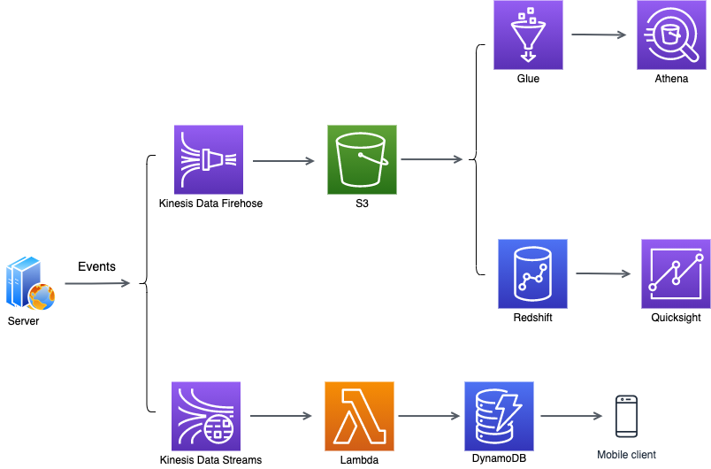

**The Data Flow:**

* Kinesis Data Firehose – To capture data from events being generated on Amazon EC2 instance which will be monitored by Kinesis Agent.
* S3 – Publish the events coming from Kinesis Data Firehouse into a data lake house in S3 which can be used in many different ways
* AWS Glue – To infer a schema from the data lake in S3 which houses all the data. Glue Crawler will scan the data seating there in S3 and will populate the Glue Data Catalog.
* Amazon Athena – Issue queries against that data from Athena as if it were a SQL Database.
* Amazon Redshift – For building out Data Warehousing, have used Redshift Spectrum here to access the data in S3. The advantage is if we had other tables that were loaded in Redshift, we can join that data with S3 data as well.
* Amazon Quicksight – Building out Data Visualization, spin up the Amazon Quicksight to visualize the data coming from Redshift which in turn is looking at the data in S3.
* Kinesis Data Streams – Capture the events which gets generated on Amazon EC2 instance.
* AWS Lambda – Publish the data coming from Kinesis Data Streams to AWS Lambda Function.
* DynamoDB – The Lambda function which gets invoked will turn around and populate the data into DynamoDB if needed in future client app can read from.

**Kinesis Data Firehose**

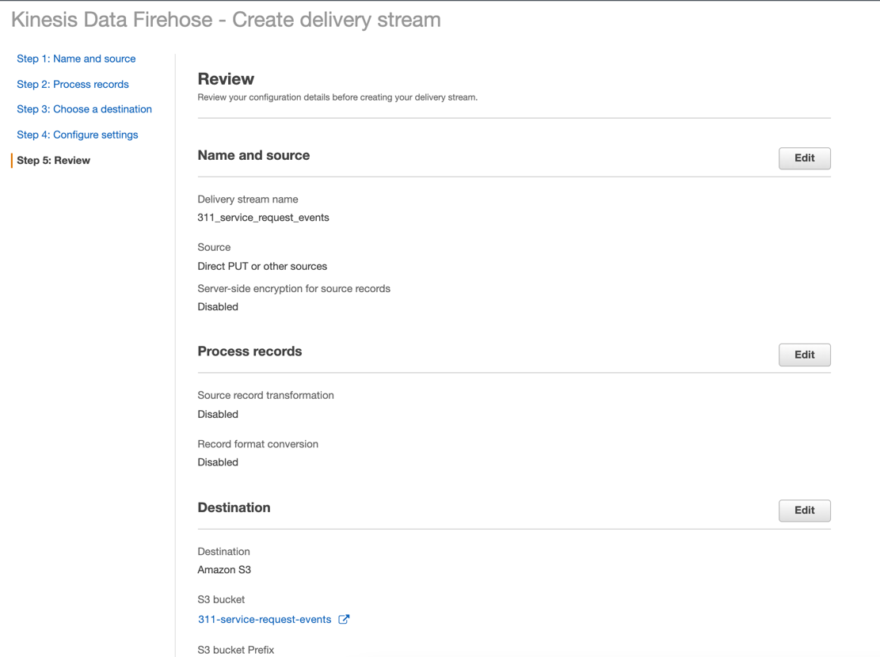

**EC2 Instance**

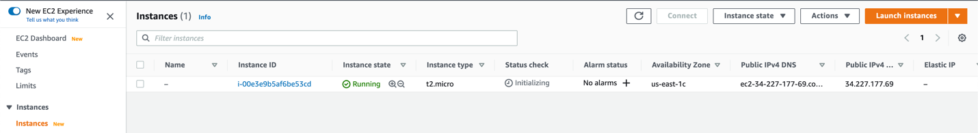

**Kinesis Agent**

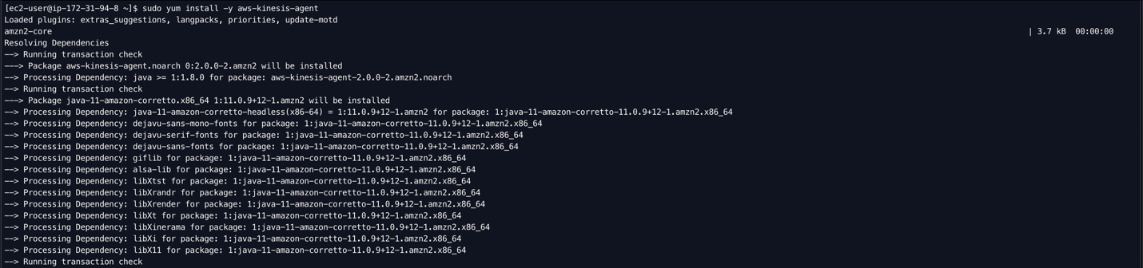

**EventGenerator.py** – Generate the events (from the csv file) into the /var/log/ directory of the instance

Generate the events into /var/log/ directory which will be monitored by Kinesis Agent.

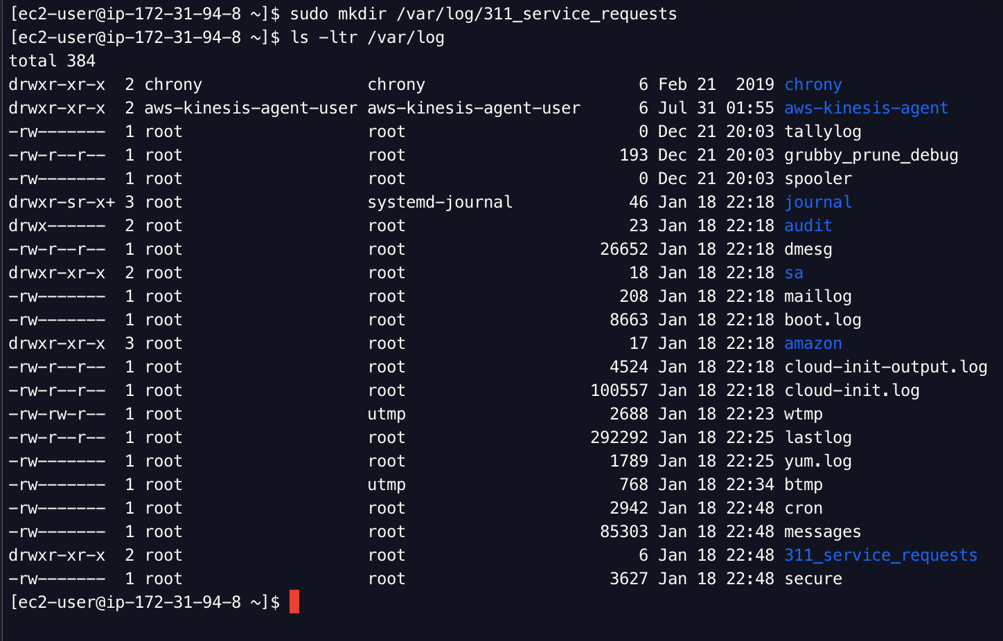

**agent.json** – Configuration file for the Kinesis Agent

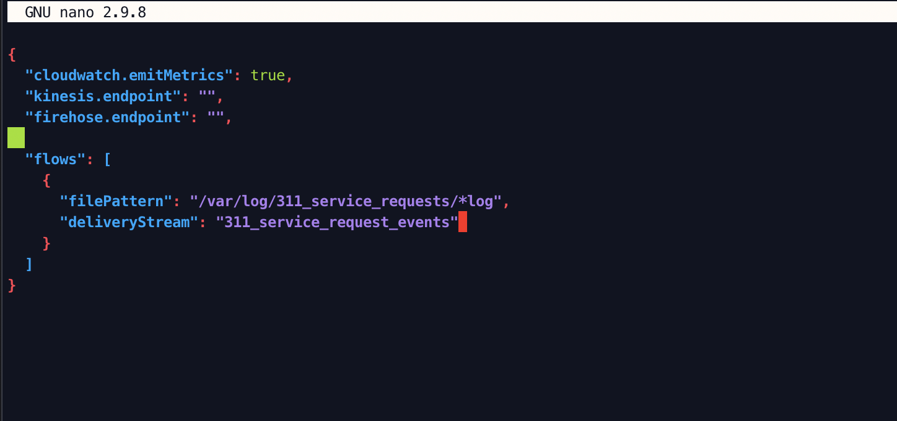

Start the Kinesis Agent

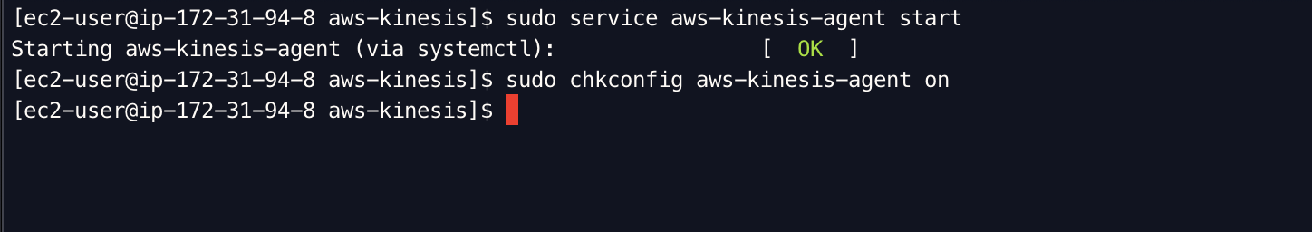

Generate the number of events

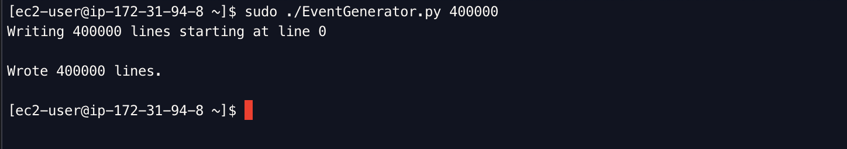

Events generated in /var/log/ directory which Kinesis Agent monitors and send it to Kinesis Data Firehose and Kinesis Data Streams.

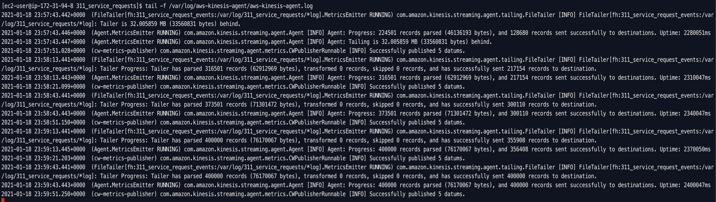

**S3 Data Lake**

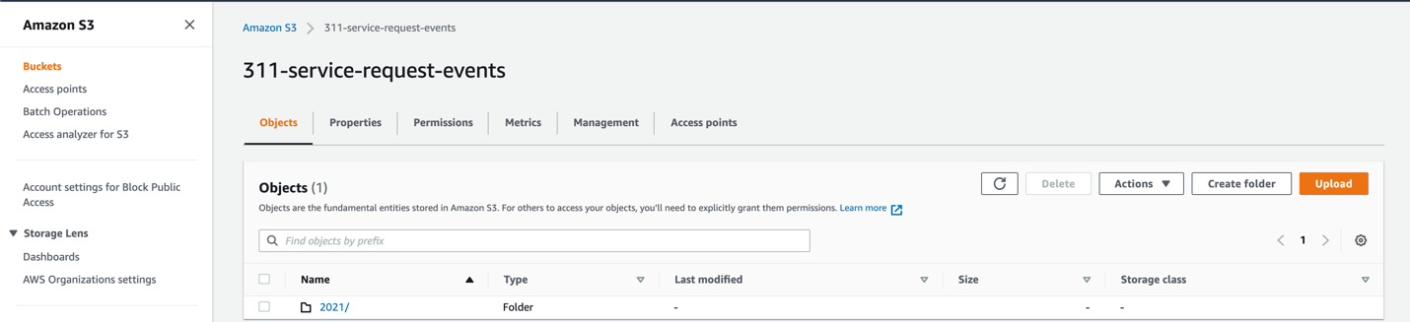

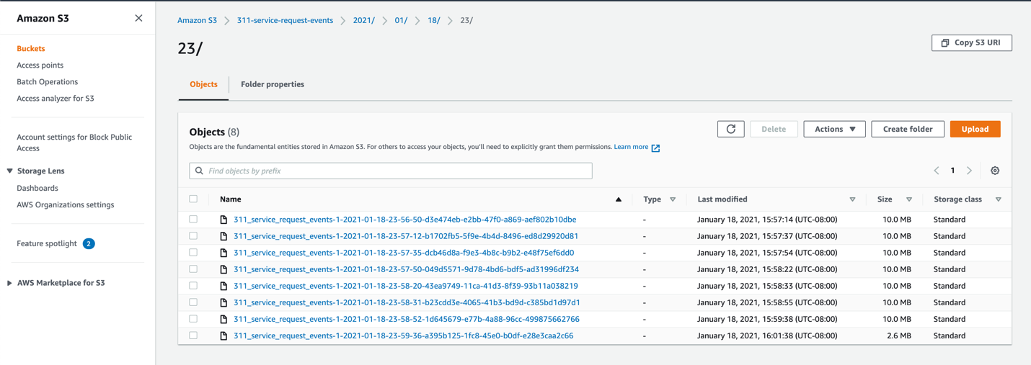

**Kinesis Data Streams**

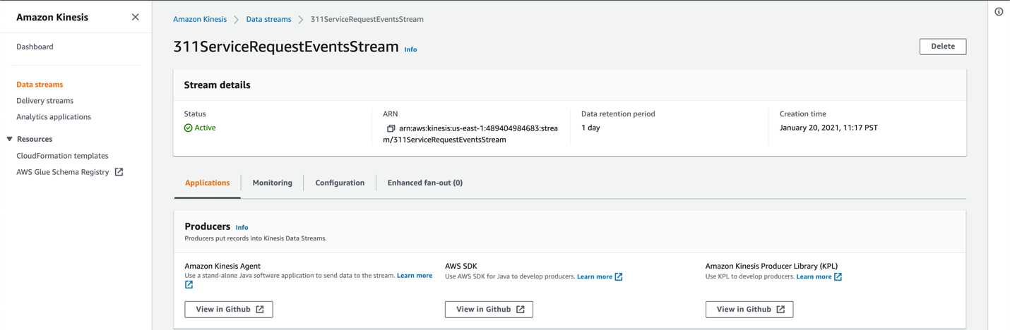

agent.json – Add the new flow here which will push the data to Kinesis Data Stream and tell the client to convert the CSV data into JSON format

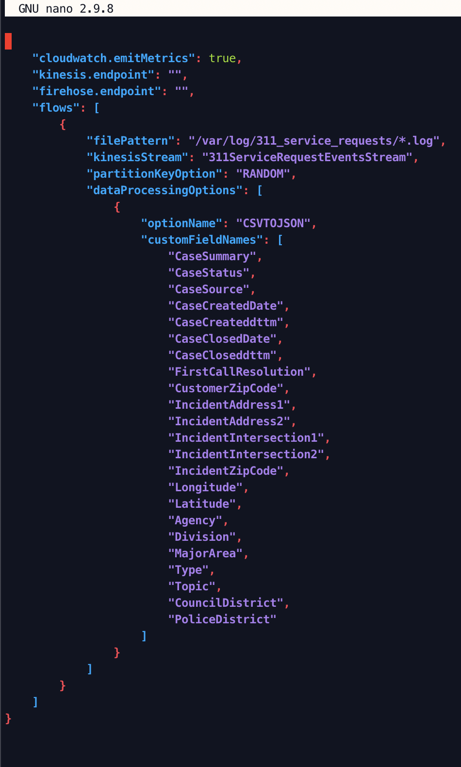

Generate the events, Kinesis Agent will monitor the events and send the data to both the flows (Kinesis Data Firehose and Kinesis Data Streams)

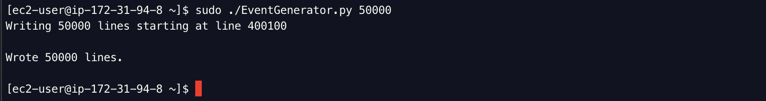

**AWS Lambda** function (lambda_function.py) running in a serverless environment that can scale itself up indefinitely and as needed will consume data from Kinesis Data Stream and write it out to DynamoDB.

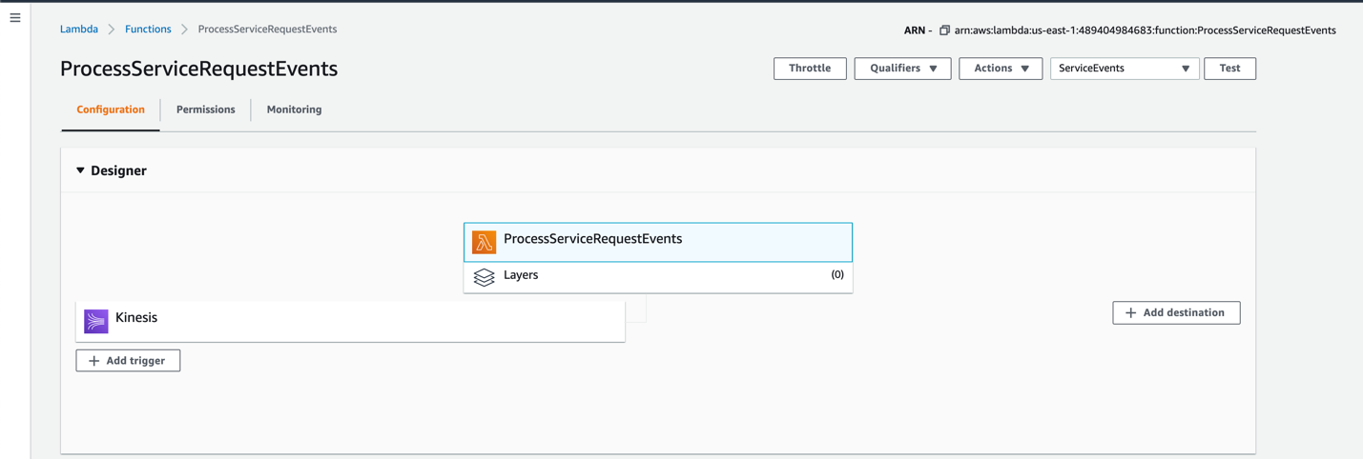

**DynamoDB**

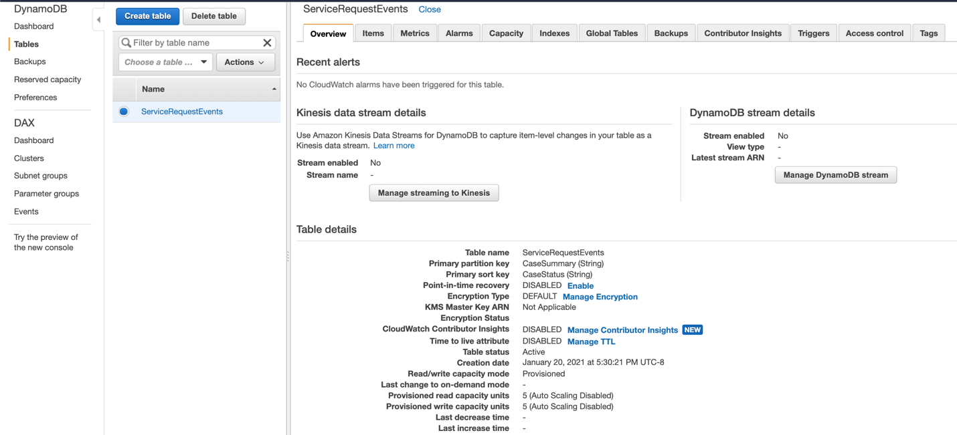

**Data Warehousing and Visualization Purpose**

**AWS Glue** – Set up AWS Glue to infer a schema from the data lake in S3 which houses all of the 311 Service Request Events and Traffic Accident data. We need to give AWS Glue few hints about that data is actually named.

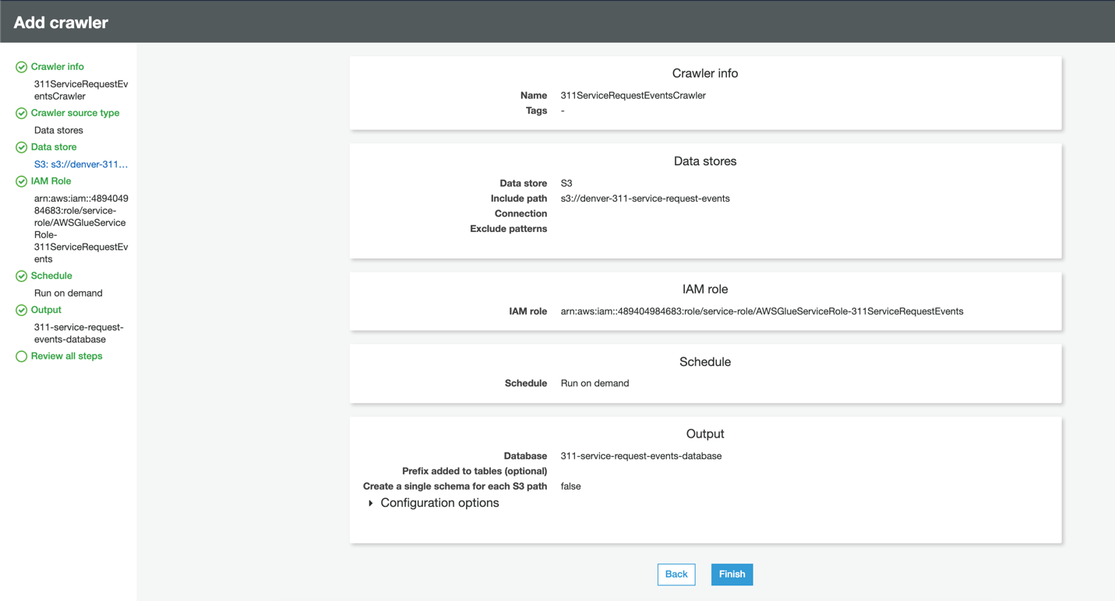

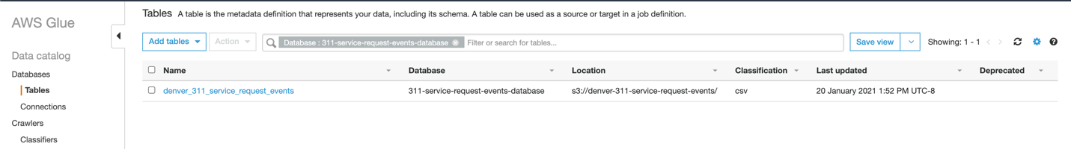

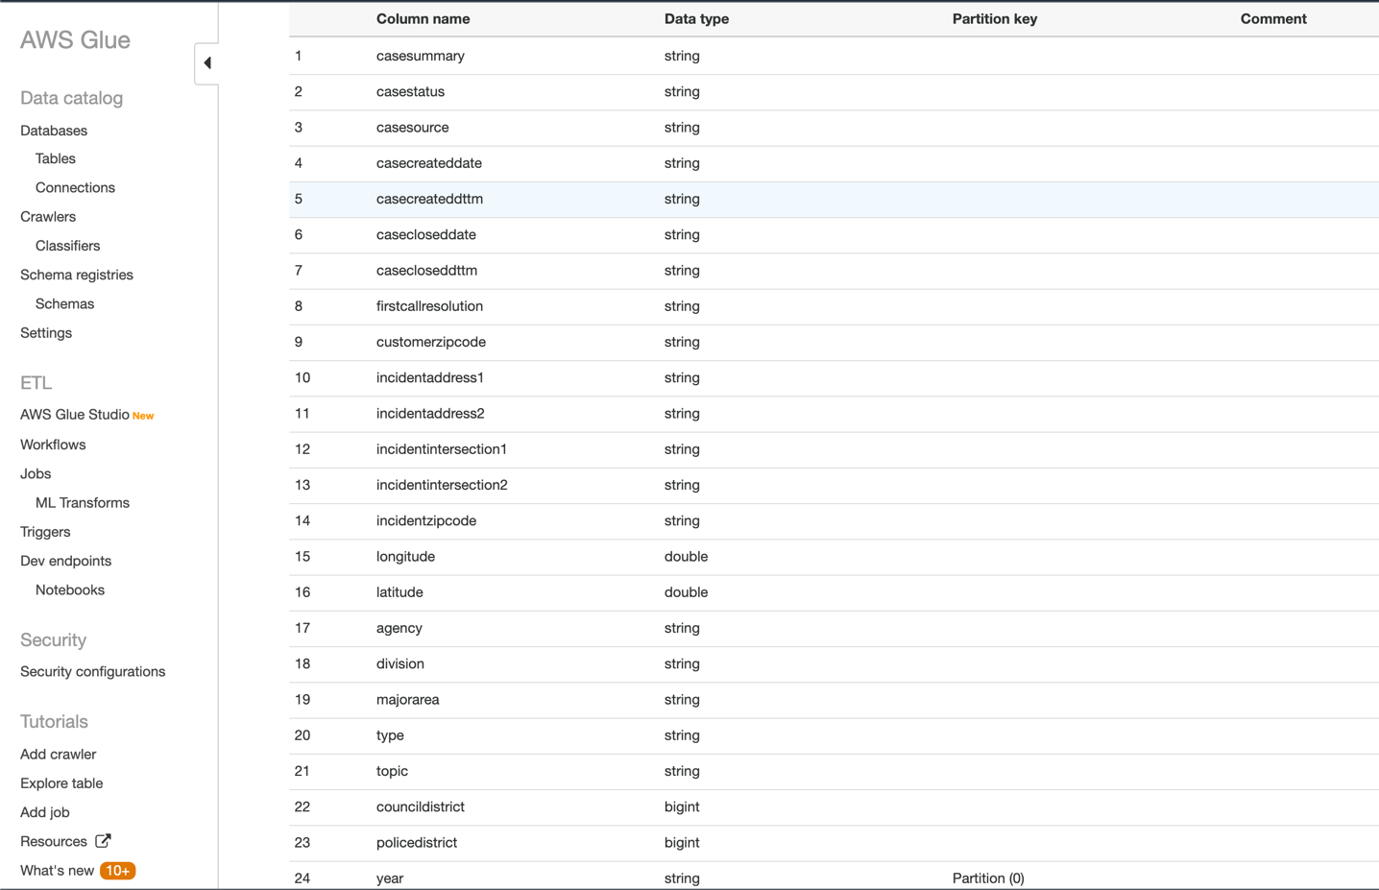

**Amazon Athena** – Athena running through AWS Glue on an S3 data lake. The advantage of using Athena is we don’t to set up any servers, don’t have to import the database or the table it talks to Glue automatically. it provides a quick and easy way to explore your data and extract information.

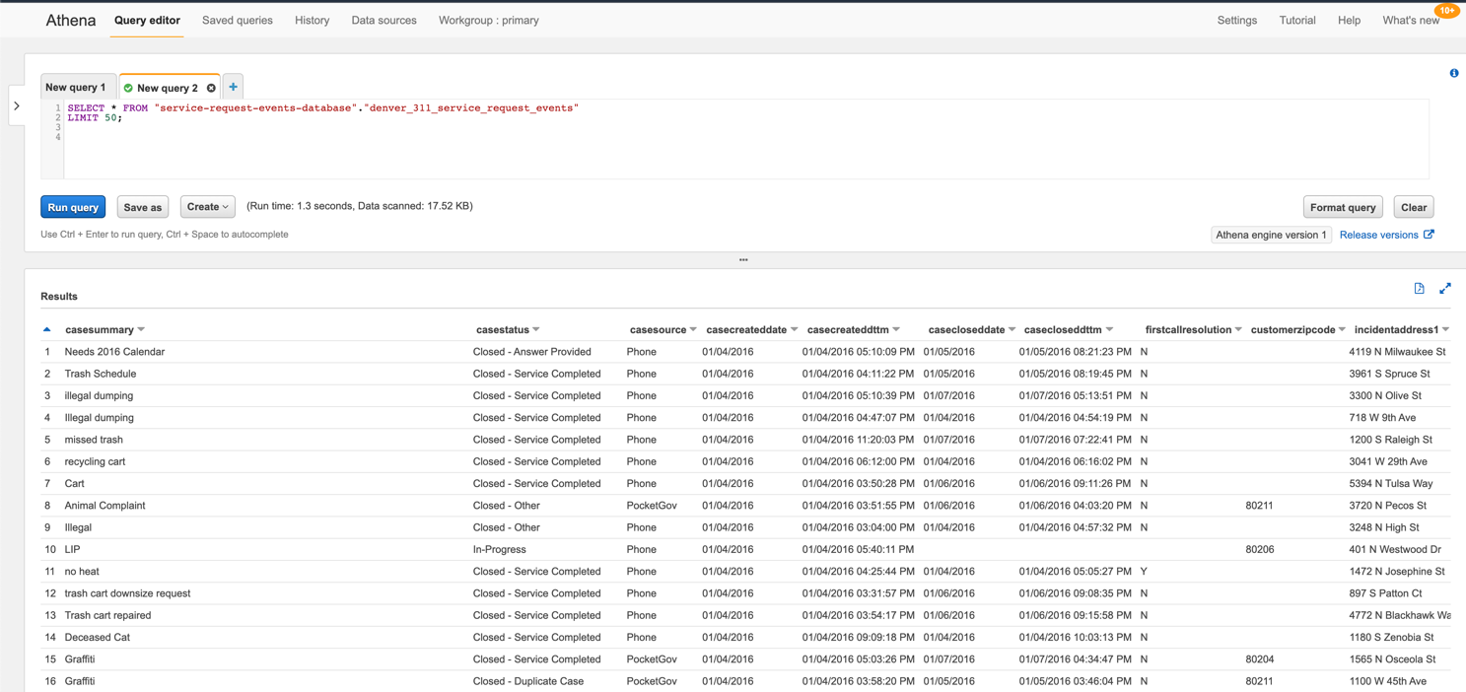

**Amazon Redshift** – Redshift Spectrum is being used here, while we could have copy that data into Redshift directly and let it just sit within the Redshift, why have a copy of the data if not needed since we have AWS Glue in place that can expose data to Redshift Spectrum and we can query the data directly.

Advantage of using Redshift Spectrum is if we had other tables loaded into Redshift, we join that S3 data with the other data as well.

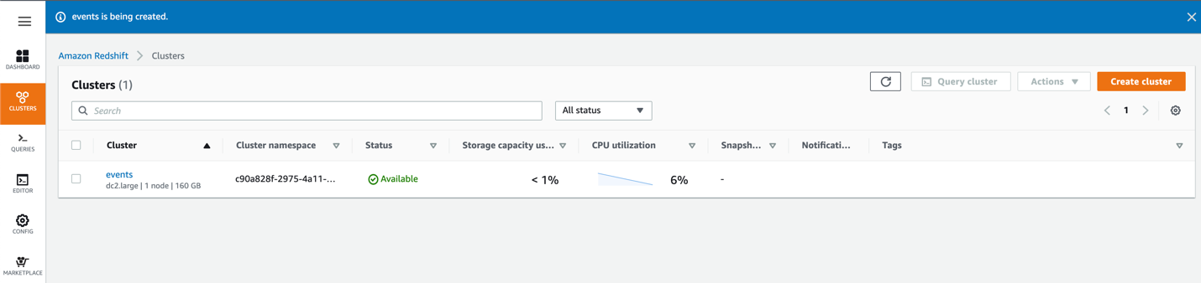

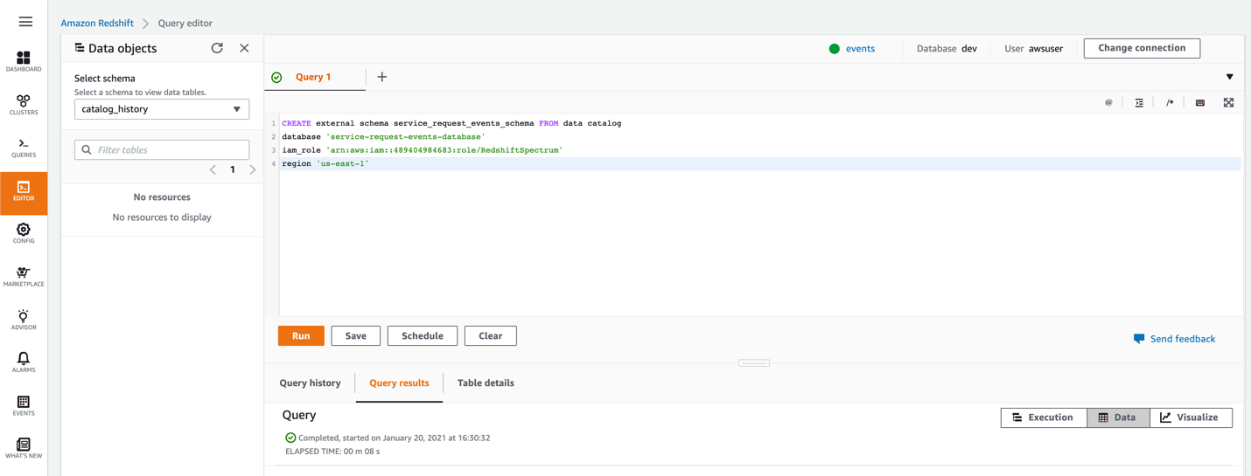

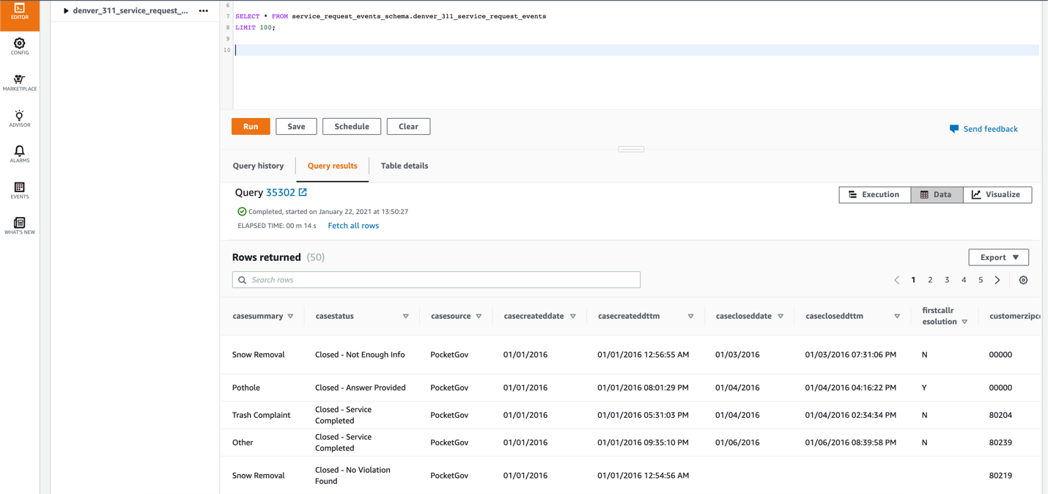

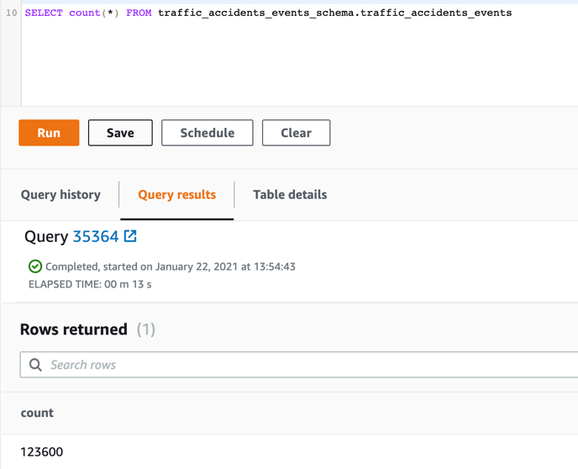

**Amazon QuickSight** – Spin up QuickSight to visualize the data coming out of Redshift which in turn is looking at the data in Amazon S3.

**What is the monthly trends in the total number of cases in Denver City?**

**Monthly Trend, Total Number of Cases**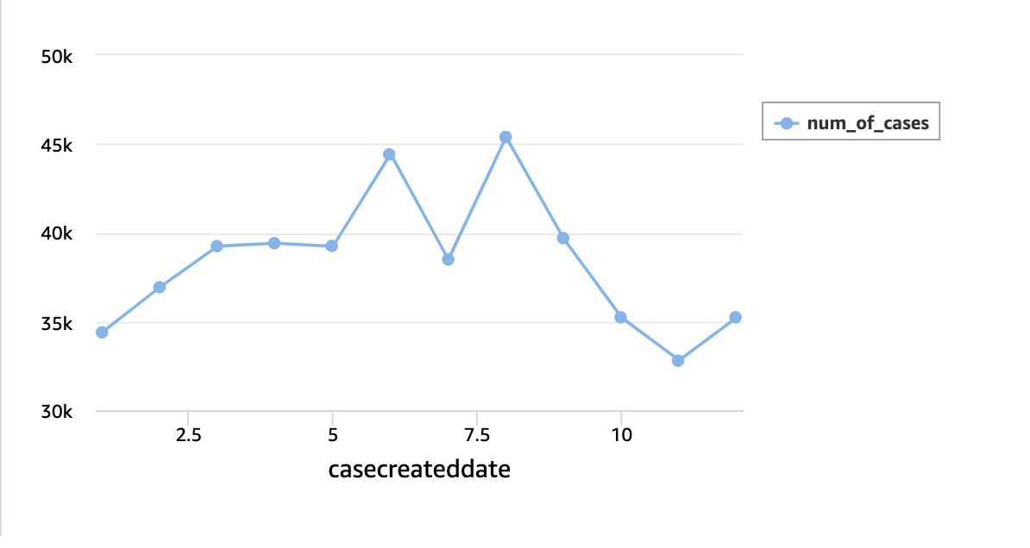

**How are the cases distributed by geographic area?**

**Number of Cases, By Area**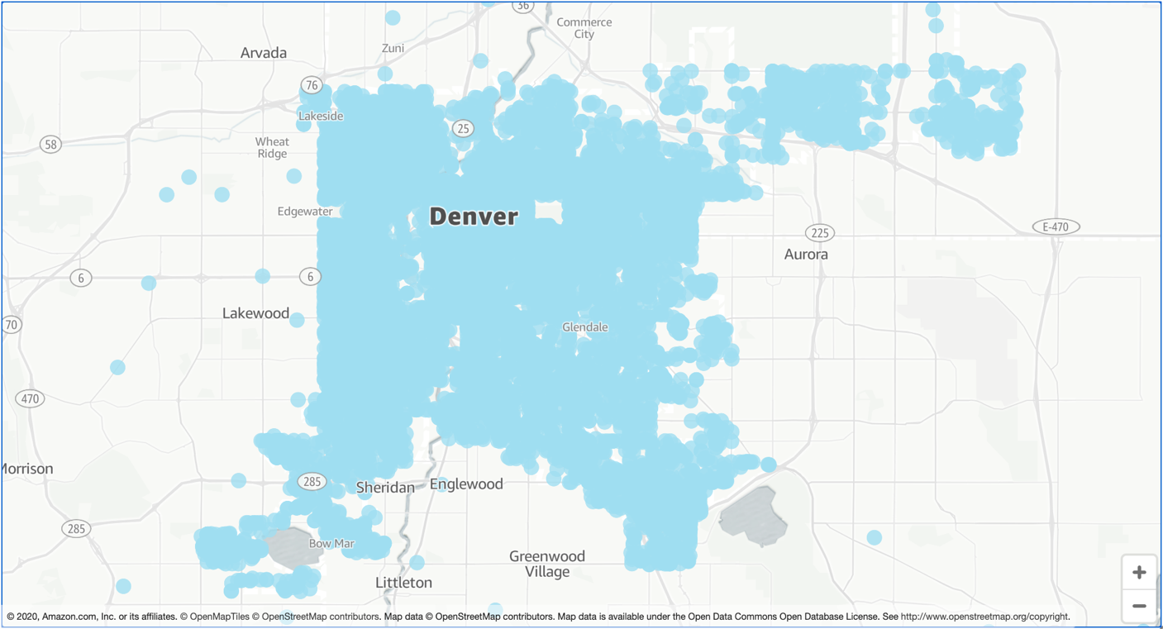

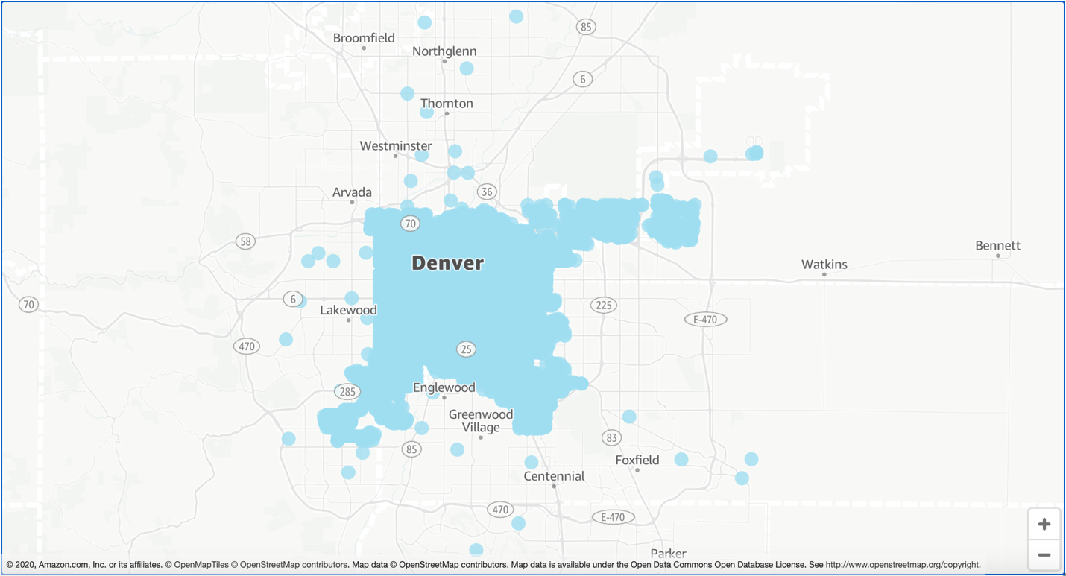

**Through which source most requests are generated?**

**Cases Generated by Source**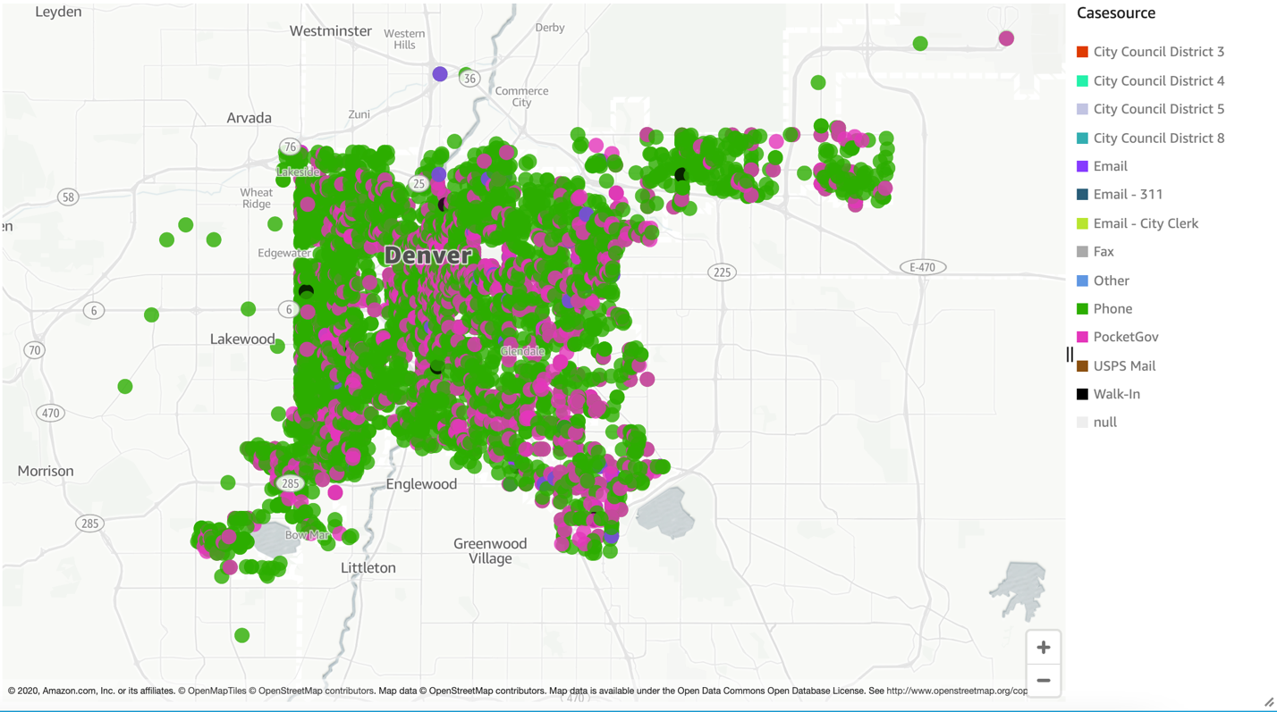

**Is the Resolution done on the First Call?**

**First Call Resolution Distribution**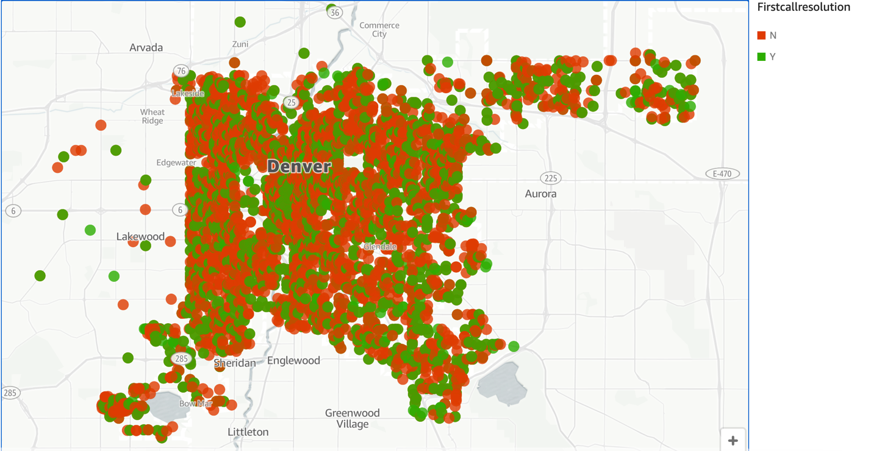

**Top 5 events common in an area?**

**Top 5 Events in an Area**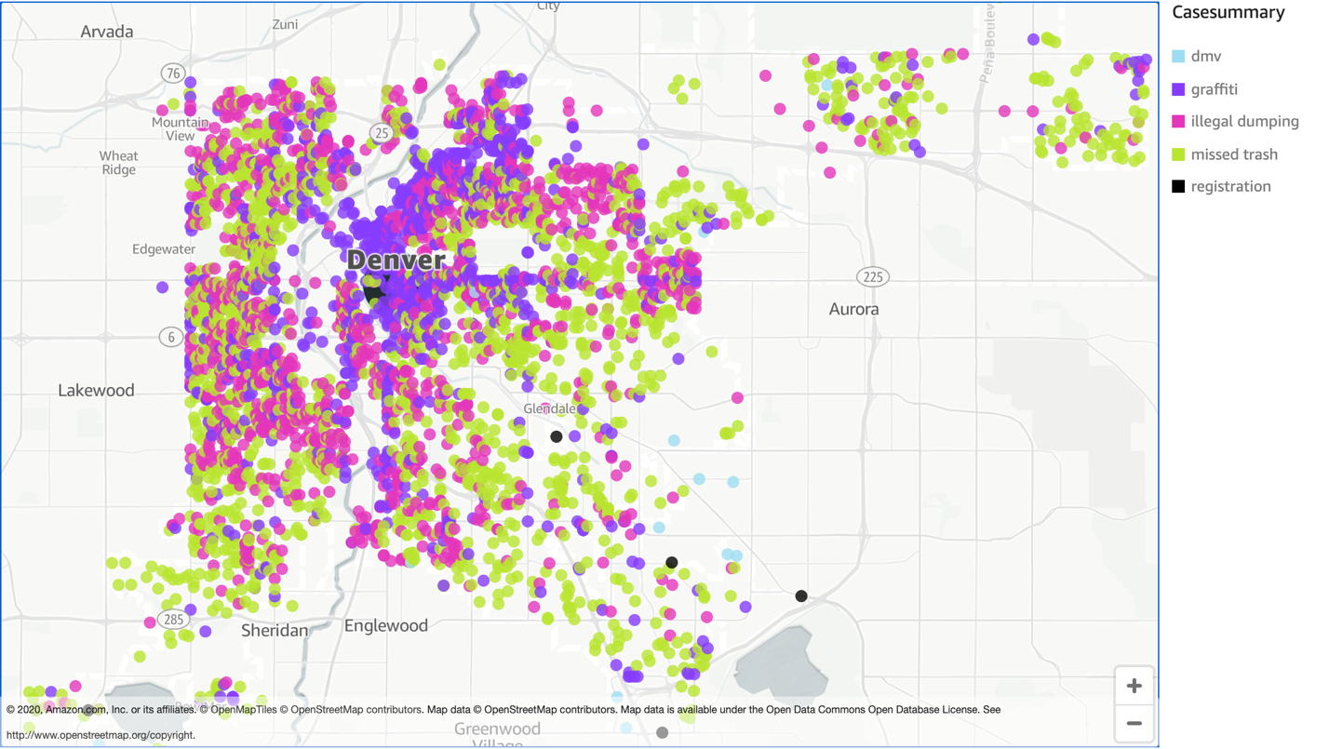

**Which are the Top Ten busiest departments?**

**Ten Most Busy Departments**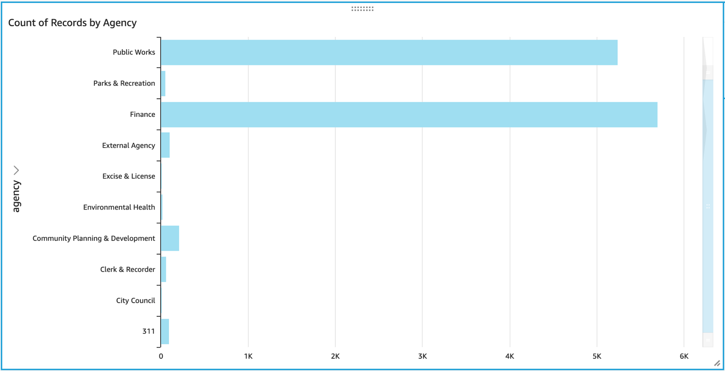

**Percentage of case status between Resolved and Unresolved?**

**Case Status Ratio**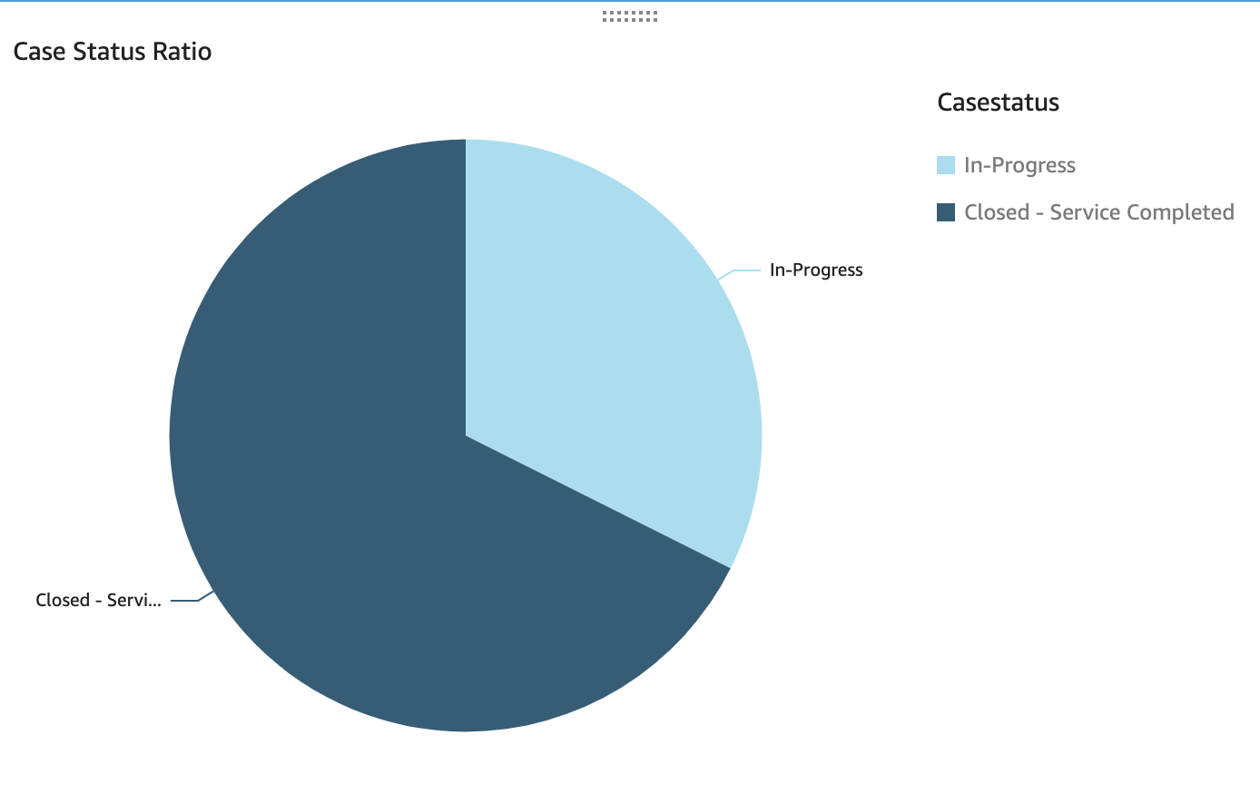

**Type of Case Area wise?**

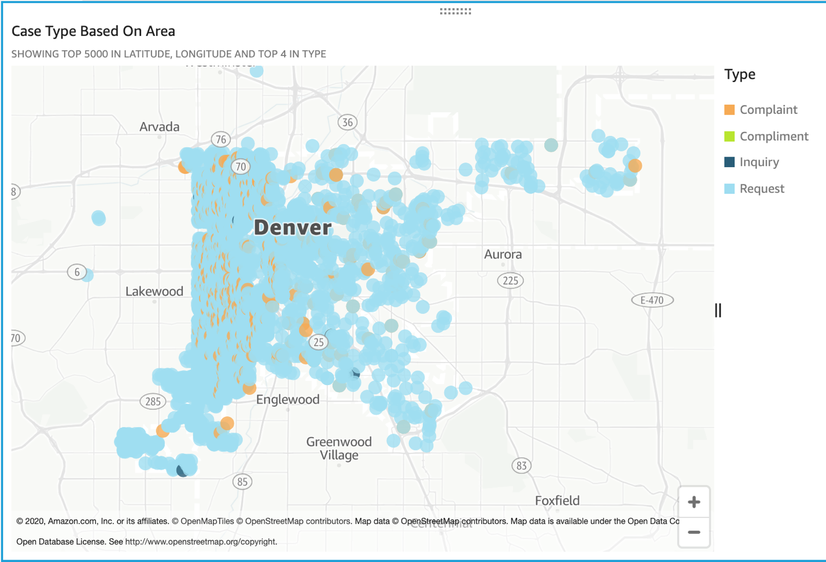

**Top Ten Most Common Cases?**

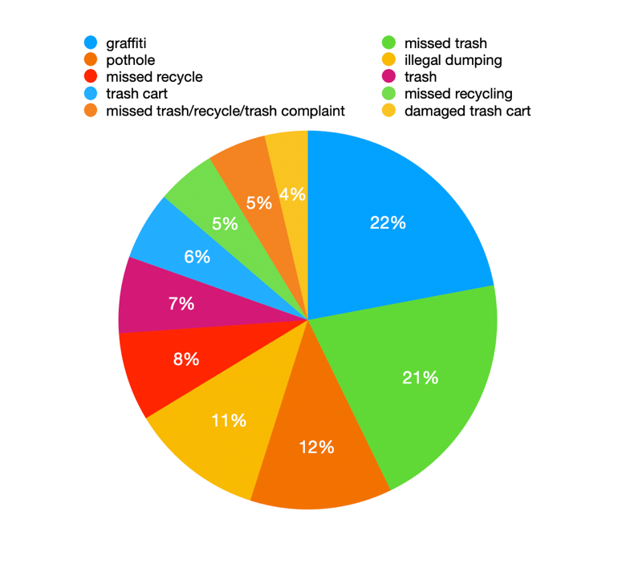

**Monthly Volume?**

**Monthly Volume of Service Requests**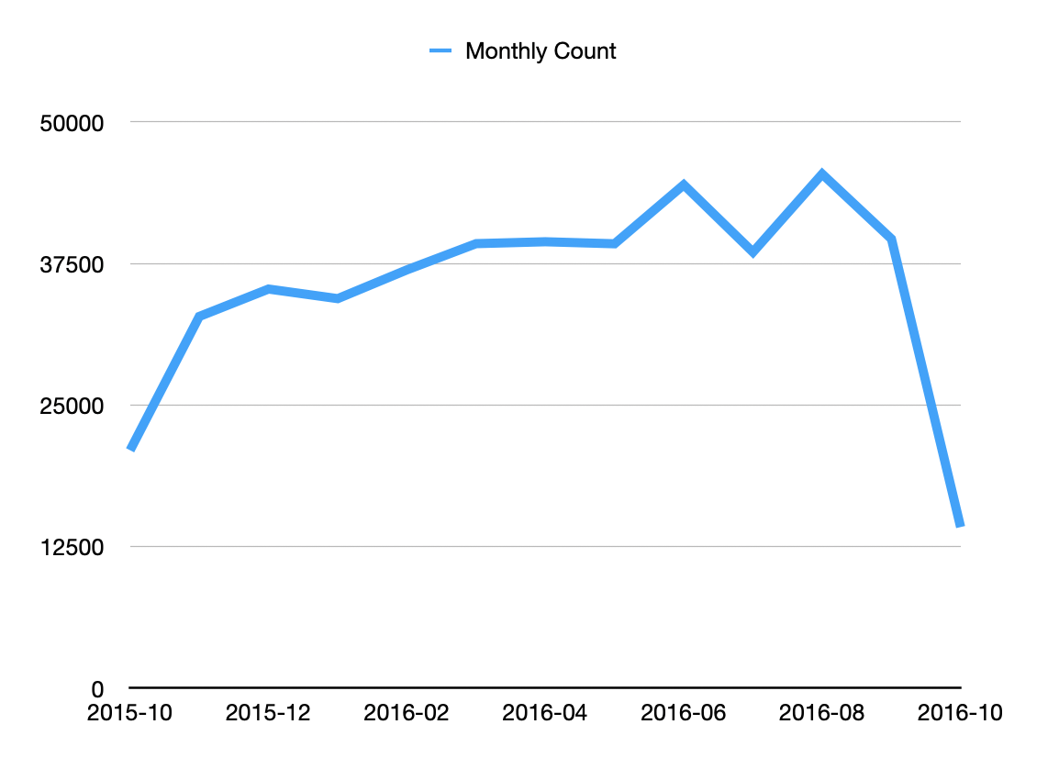

**At what time most request is made at (hourly)?**

**Service Request Calls by Hourly**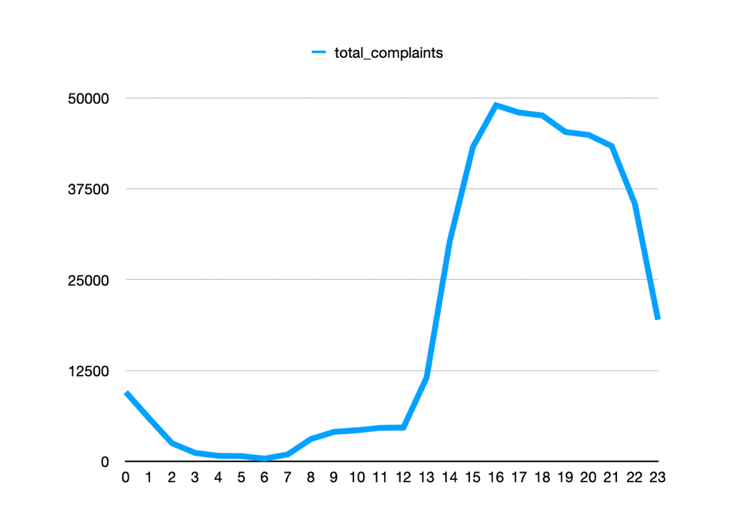

**Type of Accidents in an Area?**

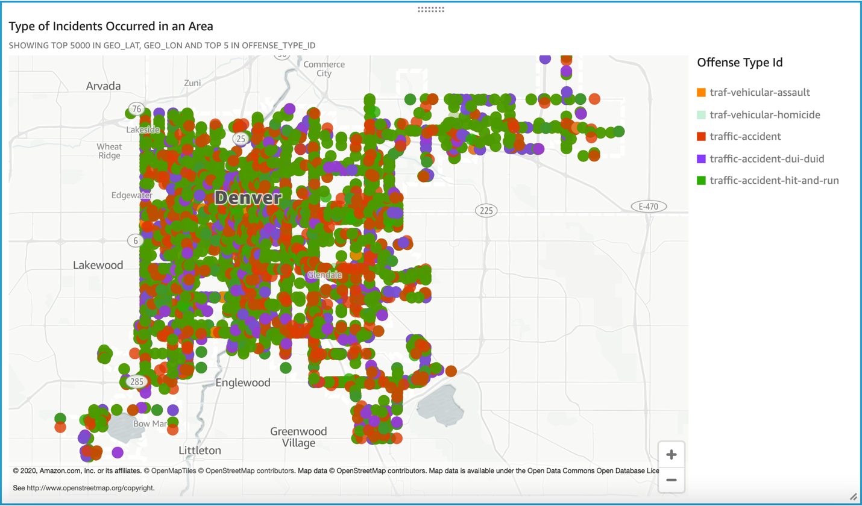

**Number of traffic accidents happening around neighborhood?**

**Total Number of Traffic Accidents Near Neighborhood**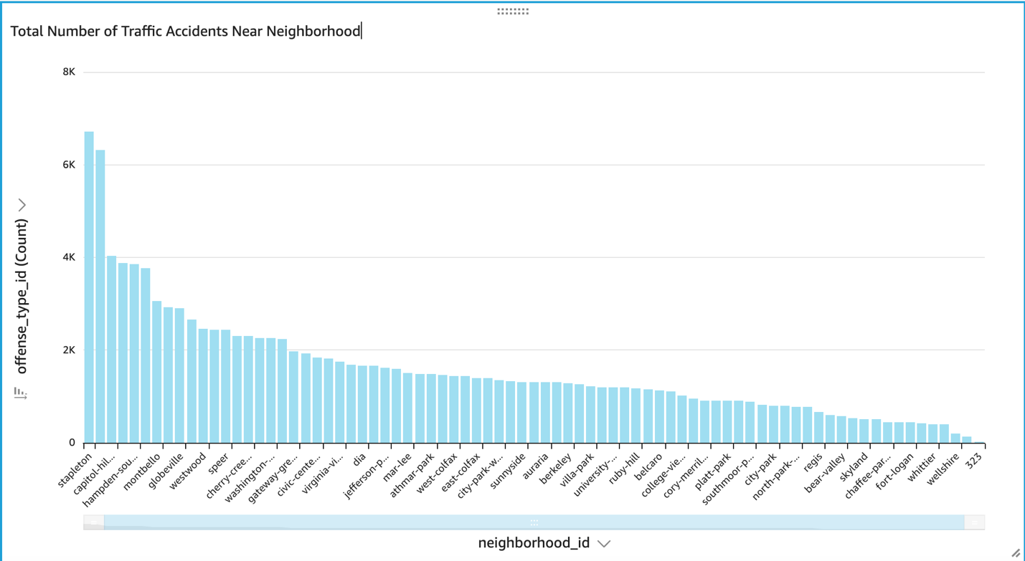

**Future Scope**

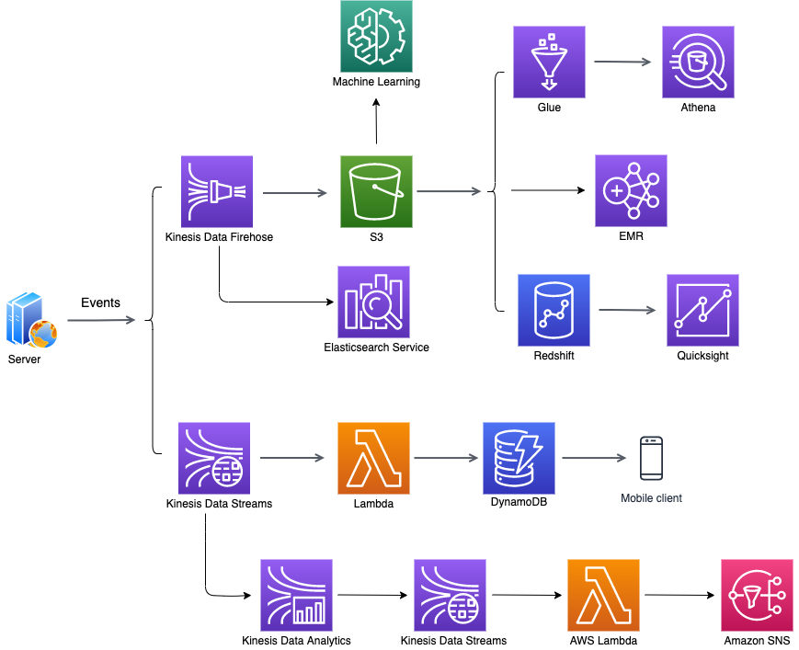

**Amazon EMR** – We can publish service request events through Kinesis Firehose into a data lake hosted in Amazon S3 and spin up Amazon Elastic Map Reduce Cluster to process huge volume of data using Apache Spark.

**Kinesis Data Analytics** – We can create an operational system that alerts us if unexpected rate of request events comes in all of a sudden which will need someone to work in real time. We can use Kinesis Data Streams and Kinesis Data Analytics to monitor the events and use lambda function to send a notification using Amazon SNS.

**Amazon Elasticsearch Service** – To Analyze event data in near real time for operational purposes. For this we can use Kinesis Data Firehose that will pump the data directly into Elasticsearch service where we can easily query that data and build dashboards for it using Kibana.